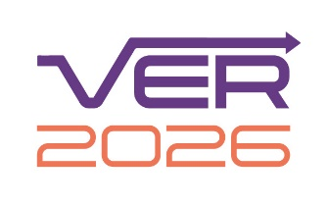 | Creative environment assessment form | 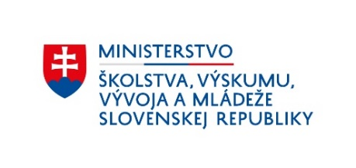

Applicant:

Fill in the name of the institution or part of the institution on behalf of which you are
submitting the application.

Unit of assessment:

Specify the research area in which you are submitting the application.

Context, mission and scientific profiling:

Provide an overview of the structure, mission and scientific profile of the applicant for which you are submitting the application, or the appropriate organisational unit.

In this part, provide organisational components (e.g. departments or other units), and possible specialisations of the research area (scientific profiling).
Word limit: max. 500 words

Strategy:

Explain the applicant's (or its part) strategies in research, artistic activity and in supporting and realising societal impact for the next five-year period (2025-2029).

In this part, the applicant lists and describes the plans, future strategic objectives and research and societal impact goals that it intends to achieve in the next period (2025-2029), explaining how they relate to the structure of the workplace or the relevant part of the institution and how it intends to achieve them, considering the context, mission and scientific profiling.

Word limit: max. 750 words

Collaboration and contribution to the research field, economy and society:

Provide information on the research collaboration or artistic collaboration and scientific partnerships or artistic partnerships of the submitting institution (including relationships with key research users, beneficiaries or the public).

Word limit: max. 750 words

Employees:

Explain the institution's strategies and procedures for staffing, support and training of university teachers, researchers and doctoral students.

Word limit: max. 750 words

Doctoral studies:
Provide up to 5 references to doctoral theses defended at your institution in the respective research area, during the period from 1.1.2020 to 31.12.2024. The doctoral theses should document the context, mission, scientific profiling and strategy of your institution in the respective research area (use links to the Central Register of Theses - CRZP).

For applications in the artistic research areas - Performing Arts and Related Art Fields and Visual Arts and Related Art Fields - you may include in this text box a link to a page where you provide a link to the CRZP for each doctoral thesis, but also a link to the documentation of the creative work (within this space you may provide a link to an audio-visual recording or other part of the doctoral thesis that is not included in the document uploaded in the CRZP).

If you are submitting application in a research area in which accreditation for doctoral studies is not granted, you do not provide hyperlinks to defended dissertations. If the applicant does not offer doctoral programmes despite the possibility of accreditation in the relevant research area, the applicant provides a justification in the application.

Income, infrastructure and facilities:
- Describe the material and technical facilities available to the institution to support research or artistic activities and to enable or contribute to its societal impact.

Word limit: max. 400 words
- Indicate the amount of funding received for science and research from the
state budget allocation during the assessed period 1.1.2020 - 31.12.2024. (EUR)
- to be filled out by the respective department of the Ministry of Education, Research, Development and Youth of the Slovak Republic

- Please indicate the amount of funds received for science and research in a
competitive way (grants) during the evaluated period 1.1.2020 - 31.12.2024 from
the state budget or from the European Union sources. (EUR) - to be filled out by
the respective department of the Ministry of Education, Research, Development
and Youth of the Slovak Republic
- Indicate the amount of funding received during the assessed period 1.1.2020 -
31.12.2024 from other than state and public sources. (EUR) - to be filled out by
the respective department of the Ministry of Education, Research, Development
and Youth of the Slovak Republic

